Crescent City  Fireball Festival  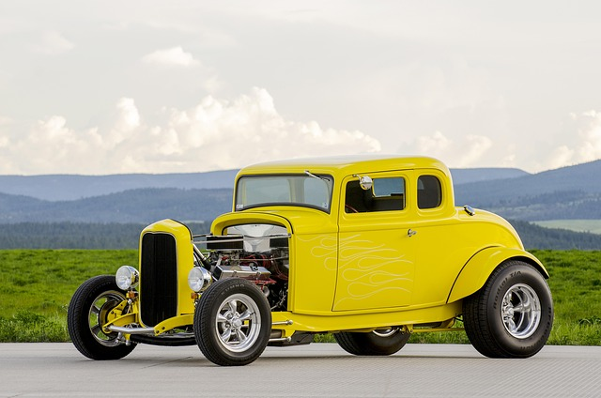  car show  June 14th  Registration 12pm – 1pm  Show 1pm – 4pm  Town Cruise 4pm  Where  Crescent City, IL  IL Route 24,  East side of town at the site of the old High School.  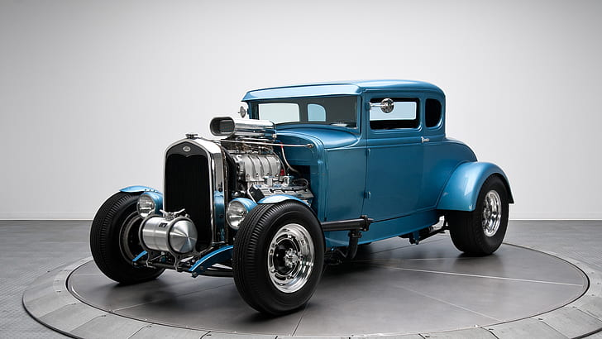 | entry fee  Suggested Donation  $10  trophies  People’s Choice  Participant’s Choice  Judging  All spectators will receive a ballot card for their choice of the best car and each participant will receive a ballot card for their choice of best car.  Benefiting  Entry fees benefit the Crescent City Fireball Festival.  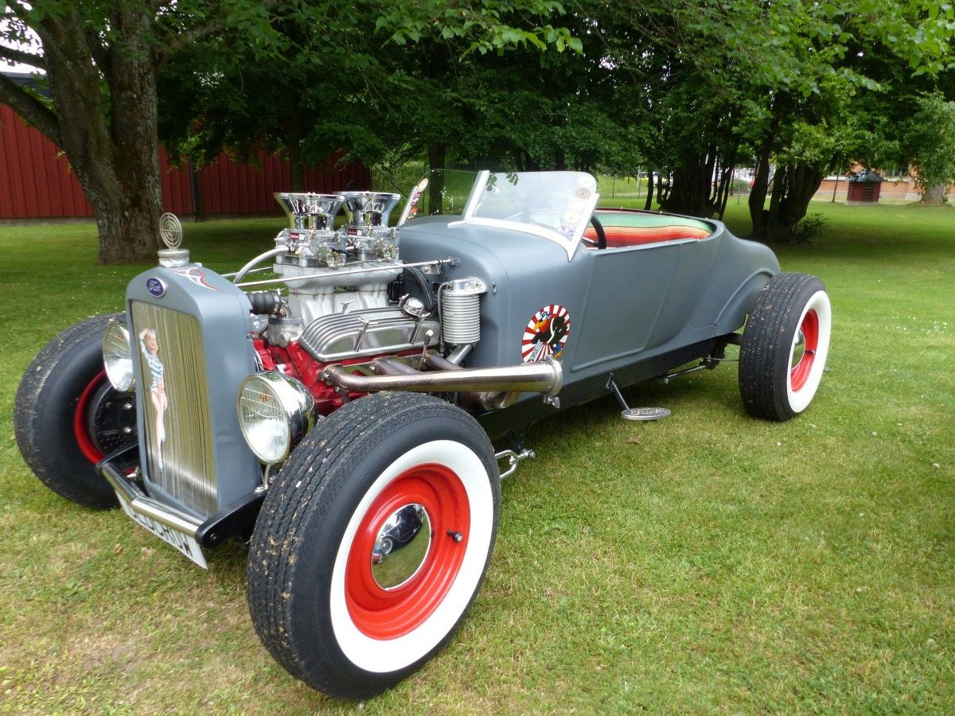  50-50 raffle proceeds benefit the Crescent City Fire Protection District.

